Optical Fiber Attenuation
Teacher Edition
Subject(s)/Course(s): Algebra | Grade Level:  High School | Duration: One 80min Class or Two 40min Classes
Lesson Synopsis/Narrative:
The school wants to install a 50 meter plastic fiber optic cable for their datacom needs that will connect two sections of the school together. The students are given the task to determine if this is possible given that there is a large power loss over distance in plastic fiber. If running 50 meters of plastic fiber without significant signal losses is possible, at what wavelength should the transmission be sent?
Prior Knowledge:
Graphing with spreadsheets or by hand. Having students utilize Google Sheets or Microsoft Excel is a 21st Century skill that many employers are looking for.
The ability to read the equation of the line and find the slope of the line.
Background information:
There are no industry standards for how the efficiency of fiber optic transmission is measured. As a result the customer and the vendor need to be in agreement with the requirements and process that is to be used when determining which optical fiber or transmitting wavelength gets used (this is true). Datacom transmission equipment operates between the 0 and -30dBm power range. Below this range the signal to noise ratio becomes too small to transmit data accurately.

Fiber optic works by the propagation of light through an optical core that is highly transparent. This phenomena is based on the principle of total internal reflection, where the light is reflected off of the inside surface as it propagates along the fiber. The loss of light intensity as the light propagates in the fiber is primarily due to the scattering of light when reflected on a rough or irregular surface of the fiber at the molecular level. The amount of light that gets scattered depends on the wavelength of light used. This is known as Rayleigh scattering, where shorter (blue) wavelengths are scattered more strongly than longer (red) wavelengths. This is also the reason behind why the sky is blue.
Challenging Question or Problem:
Can LEDs between 470nm and 667.5nm be used to transmit datacom information over 50 meters of plastic fiber optic cable? Which color LED would be best to use and why? What is the maximum distance that datacom information can be transmitted on a plastic fiber based on color?
Phenomenon and Manufacturing Application:
Engineering and manufacturing of fiber optic cable depending on the use. The purchase and installation of fiber optic cable types depending on use.
Examples (in action):  Fiber optic transmission of phone and data used in the telecom industry. Fiber optics used in the lighting industry to transmit light without heat. http://www.absolute-action.com/file_upload/The%20Benefits%20and%20Usage%20of%20Fibre%20Optics.for%20publication.pdf |  |  | Vocabulary:  Fiber Optic  Wavelength  Power  Intensity  Rayleigh Scattering  Absorption  Bending  Decibel  Light Emitting Diode
State and National Standards & 21st Century Skills:
AI-A.CED.1 - Create equations and inequalities in one variable to represent a real-world context.
AI-A.CED.2 - Create equations and linear inequalities in two variables to represent a real-world context.
Practices MP.2 - Students are reasoning abstractly when they create abstract algebraic models of problems
Practices MP.8 - An effective way to help students develop the skill of describing general relationships is to work through several specific examples and then express what they are doing with algebraic symbolism

AI-S.ID.5 - Summarize categorical data for two categories in two-way frequency tables. Interpret relative frequencies in the context of the data (including joint, marginal, and conditional relative frequencies). Recognize possible associations and trends in the data.
AI-S.ID.6 - Represent bivariate data on a scatter plot, and describe how the variables’ values are related.
AI-S.ID.6a - Fit a function to real-world data; use functions fitted to data to solve problems in the context of data.
AI-S.ID.7 - Interpret the slope (rate of change) and the intercept (constant term) of a linear model in the context of the data.
AI-S.ID.8 - Calculate (using technology) and interpret the correlation coefficient of a linear fit.
AI-S.ID.9 - Distinguish between correlation and causation.
AI-F.LE.5 - Interpret the parameters in a linear or exponential function in terms of a context.

Learning Targets:
- Students will create a plot and fit a function to the data in order to answer the question.
- Students will recognize associations and trends in the plotted data, interpreting the slopes of the line.
- Students will describe how the variables of frequency and distance are related.
- Students will use the equation for each trendline to predict the attenuation loss at 50 meters and the maximum distance of fiber optic that can be run.
Materials and Equipment Per Group:
1 Breadboard
1 Red, yellow, green, and blue LED
1 Battery box with batteries
10 Alligator leads
1 0.5m fiber optic cable
1 10m fiber optic cable
1 20m fiber optic cable
1 30m fiber optic cable
1 photometer

Also in kit:
LED Tester
Materials not provided in kit, preparation/time:
If taking data, be sure to read the operator’s manual for the digital photometer and to become familiar with all equipment prior to starting the lesson.
Safety:
If the leads from the battery box get connected together (shorted) while the battery box switch is in the on position, the batteries and wire will heat up and could cause burns.
Procedure and Prompts:
Teacher Does and Says | Student Does and Says
Introduction:
Facilitate students reading the article as a warmup and then discuss fiber optics. | Students read “fiber optics” and answer the following question.  New York State would like to update the data communications infrastructure across the state in hopes of attracting more businesses. Compose a conclusion or claim that states why or why not the infrastructure upgrades should be completed with fiber optics. Use evidence found in the article with an explanation to make your claim.
Collecting the Data: Measuring the attenuation of a fiber optic cable (Optional – See raw data to skip ahead)
Introduce to the students how a breadboard works.  https://learn.sparkfun.com/tutorials/how-to-use-a-breadboard  A good tutorial for breadboards: http://wiring.org.co/learning/tutorials/breadboard/  To shorten the time of this lesson assign each group to take data on a different color LED and have them share the data when they are done.  Alternatively students can answer only one of the challenge questions: Can LEDs of 470nm be used to transmit datacom information over 50 meters of plastic fiber optic cable? What is the maximum distance that datacom information can be transmitted on a plastic fiber based on this color? | - Connect the battery box to the breadboard by attaching the red lead to the red positive terminal strip on the breadboard and the black lead to the negative blue terminal strip on the breadboard. Turn the battery box on.  - Wire one blue 5mm LED in parallel on the same terminal strip of the breadboard according to the schematic. The positive side of the LED is the longer lead. The negative side of the LED is the shorter lead. The LED’s should light up with their respective color.
Assist students with setup. Students can get a good understanding of what a photometer is and what it is used for by reading the background in the digital photometer operator’s manual (page 1).  Slightly darken the room if possible. Bright ambient light can interfere with the quality of the data. | - Using the 0.5m fiber optic cable, attach the end that has the washer to the photometer detector assembly. This is done by inserting the fiber optic coupler into the photometer detector until the washer is flush to the surface.  - Insert the other side of the fiber optic coupler onto the blue LED on the breadboard. The coupler should simply snap over the LED.
The reading on the photometer should hold steady. If not then there’s likely an issue with how the LED is seated in the breadboard. Try removing the LED and plugging it into another section of the terminal strip on the breadboard. | - Set the photometer selector switch to the 200μW range. Press and hold the on/off switch until the reading on the photometer stabilizes, or after 15 seconds, then record the reading on the photometer in the table below.
Removing LED’s from the coupler can be difficult. Be sure to have the students grasp the leads of the LED firmly and pull on the coupler itself. Never pull on the fiber. | When removing connections from the couplers, never pull of the fiber optic cable. Always have a firm grip on the coupler and LED itself.  - Remove the blue LED from the breadboard and the coupler. Insert a green LED into the coupler and then plug the LED into the breadboard. You should see the green LED light up.  - Repeat step 5.
Remember; never pull of the fiber optic cable. Always have a firm grip on the coupler and LED itself.

- Remove the green LED from the breadboard and the coupler. Insert a yellow LED into the coupler and then plug the LED into the breadboard. You should see the yellow LED light up.

- Change the photometer selector switch to the 20μW range. Press and hold the on/off switch until the reading on the photometer stabilizes, or after 15 seconds, then record the reading on the photometer in the table below.
 | - Repeat steps eight and nine for the Red LED.
See Table 1 below for an example of data | - Replace the 0.5 m fiber optic with the 10 m fiber optic and repeat steps 2 through 9.  Be careful when removing the photometer detector. Make sure you have a firm grip on the coupler and the photometer detector, never pull on the fiber optic itself.
 | - Replace the fiber optic cable with the 20 m and finally the 30 m cable after repeating steps 2 through 9.
Powers of ten conversions: microwatts is 10⁻⁶ and milliwatts is 10⁻³  See Table 2 below for an example of converted data | - Convert the light power from microwatts (μW) to milliwatts (mW). Record your results in the table below?
Reducing the Data
If you have chosen to skip the data collection provide Table 2 (see below) for the students to use.  Resources on fiber optics/attenuation:  https://www.newport.com/t/fiber-optic-basics  http://www.photonics.com/EDU/Handbook.aspx?AID=25151  On bending fiber:  http://www.thefoa.org/tech/ref/fiber/BIfiber.html  The teacher can give the students the Rayleigh scattering, absorption, and bending terms.  Rayleigh Scattering is the scattering of light off of molecular defects in the fiber. Microscopic defects in the variation of the index of refraction of the core in fiber optics can cause considerable scattering, leading to substantial losses of optical power. The amount of Rayleigh scattering depends on the wavelength of light used. Rayleigh scattering is less significant at longer wavelengths. This is the most significant loss mechanism in optical fiber, generally accounting for up to 90 percent of the loss that is experienced.  Absorption occurs when the energy of a photon is taken up by matter, in this case impurities (such as water). In absorption the electromagnetic energy is converted into heat or internal energy of the absorber. Currently, modern advanced manufacturing techniques have reduced absorption caused by impurities to extremely low levels.  Fiber optics are sensitive to bending. When stressed through bending, some of the light can propagate through the fiber at less than the critical angle, which results in light being absorbed by the cladding.  Students should answer that a logarithm is the inverse operation to a base (or number) with an exponent. Therefore the exponential function of decreasing power will turn into a linear function of decreasing power upon conversion. | As light propagates through the fiber optic, the light intensity decreases exponentially as a function of distance.  There are several causes of attenuation in an optical fiber: Rayleigh scattering, absorption, and optical fiber bending. Research each of these terms and fill out the vocabulary table below.  To counter this exponential loss, attenuation is measured in decibels. The decibel (dB) is a logarithmic unit that is used to express the ratio of intensity to a standard reference value.  - What will happen to the exponential function of decreasing power loss when we convert the power to decibels? Explain your reasoning.
Resource on dBm:  https://en.wikipedia.org/wiki/DBm  See Table 3 below for an example of dBm converted data | Decibels need to have a standard reference value. Attenuation loses in industry base that standard reference value on 1 milliwatt, or 1mW. Decibels based on the 1mW standard reference value are often referred to as decibel-milliwatts or dBm. Therefore, a level of 0 dBm is equal to the power of 1 mW.  The unit conversion of power (in milliwatts) to dBm is  $$dBm=10l{og}_{10}\frac{P(mW)}{1mW}$$  - Convert the light power from milliwatts to decibels of light (dBm) in the table below.
See graph 1 below for an example | - Create an attenuation graph for decibels (dBm) vs distance of fiber (m).
 | - Using the graph, create a line of best fit and determine the equation for the line of best fit assuming a linear relationship.
The student should set y equal to -30dBm and solve for x (distance m).  Maximum usable transmission distance using the example data below:  Blue = 109m  Green = 144m  Yellow = 9.20m  Red = 32.6m | Datacom transmission equipment operates between the 0 and -30dBm power range. Below this range the signal to noise ratio becomes too small to transmit data accurately.  - Determine the maximum usable transmission range for red, yellow, green, and blue LED’s. Show all work below.
Students should find that the green and blue LED’s used in the experiment are sufficient to transmit datacom information over 50 meters of plastic fiber optic cable. The yellow and red LED’s used will not work over a 50 meter distance.  Green is the best as you will have the lowest signal loss and thus the greatest signal to noise ratio at 50m.  Green has a signal of -20.6 dBm at 50 meters, which is 9.41 dBm above the minimum -30 dBm required. | - Can the red, yellow, green, or blue LED’s be used to transmit datacom information over 50 meters of plastic fiber optic cable?  - Which color LED would be best to use and why? What is the attenuation at 50 meters for the particular color LED?

Table 1
 |  | Light Power (μW)
Color | Wavelength (nm) | 0.5m | 10m | 20m | 30m
Blue | 668 | 25.3 | 20.7 | 17.4 | 10.1
Green | 575 | 25.6 | 22.8 | 19.8 | 13.8
Yellow | 525 | 1.31 | 1.00 | 0.80 | 0.38
Red | 470 | 5.32 | 3.36 | 2.03 | 1.11

Table 2
 |  | Light Power (mW)
Color | Wavelength (nm) | 0.5m | 10m | 20m | 30m
Blue | 668 | 0.0253 | 0.0207 | 0.0152 | 0.0101
Green | 575 | 0.0256 | 0.0228 | 0.0178 | 0.0141
Yellow | 525 | 0.00131 | 0.00100 | 0.00080 | 0.00038
Red | 470 | 0.00532 | 0.00336 | 0.00203 | 0.00111

Table 3
 |  | Decibels of Light (dBm)
Color | Wavelength (nm) | 0.5m | 10m | 20m | 30m
Blue | 668 | -16.0 | -16.8 | -18.2 | -20.0
Green | 575 | -15.9 | -16.4 | -17.5 | -18.5
Yellow | 525 | -28.8 | -30.0 | -31 | -34
Red | 470 | -22.7 | -24.7 | -26.9 | -29.5

Graph 1
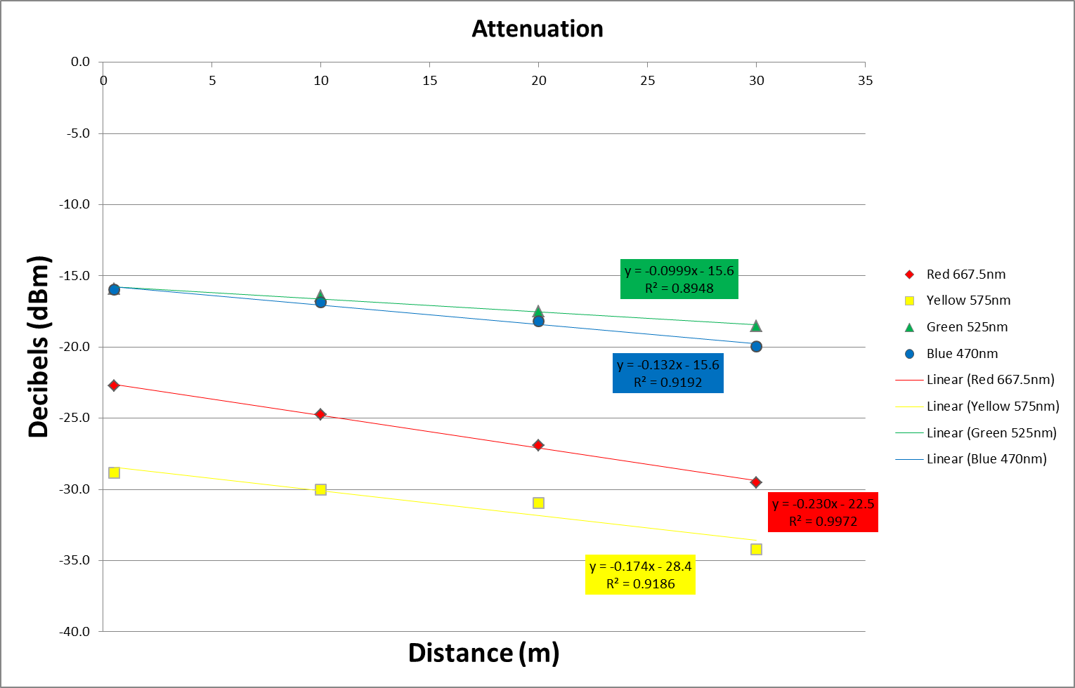

Other Graphs to Consider

